HR Data Analysis Report

**Introduction: Unlocking Insights for Informed Decision-Making**

*Prepared by: Sandesh N Christy*  
*Date: 30-10-2023*

Welcome to the HR Data Analysis Report, a comprehensive overview of the organization's human resources metrics. This report aims to provide insights into employee demographics, satisfaction levels, departmental performance, and trends over time. By examining this data, you'll gain valuable insights to support data-driven decision-making within the organization.

**Purpose of the Report**

The purpose of this report is to:

* Evaluate the current state of our workforce.
* Identify areas of improvement in employee satisfaction.
* Understand departmental performance.
* Examine trends in headcount, recruitment, and terminations.
* Promote diversity and inclusion through data-driven insights.

**Audience**

This report is intended for HR professionals, department managers, and organizational decision-makers. It is a tool to facilitate strategic planning, talent management, and diversity and inclusion initiatives. The report empowers you to make informed decisions that drive positive changes within the organization.

**Report Navigation**

* To explore specific aspects of the HR data, use the interactive filters, slicers, and visualizations provided in each section.
* The report is designed to encourage drill-down capabilities, enabling you to investigate the data at various levels of detail.

**Getting Started**

* We recommend starting with the "HR Overview Dashboard" to gain an overall understanding of the organization's HR landscape. From there, navigate to other sections as needed to dive deeper into specific areas of interest.
* In this era of data-driven decision-making, this report serves as a vital resource to optimize HR strategies and contribute to the growth and well-being of ourorganization. Your feedback and suggestions for improvement are greatly appreciate

**Data Overview**

In this section, we provide a brief description of the dataset, including key statistics and data pre-processing

Number of Records: The dataset comprises a total of 3310 employee records, representing individuals who have been part of our organization during the specified timeframe. Basic Statistics: Here are some basic statistics for key columns within the dataset:

* Age: The mean age of employees is 35.4 years, with a median age of 34 years.
* Tenure: The average tenure of employees is approximately 4.5 years, with a median tenure of 4 years.
* Pay Rate: The average pay rate across all employees is $105,000 per annum, with a median pay rate of $58,000.

Data Preprocessing: Prior to conducting the analysis, we performed data preprocessing to ensure data quality and consistency. The preprocessing steps included the following:

* Handling missing values: We addressed missing data points in the dataset by imputing values where applicable.
  + Data cleaning: We conducted data cleaning to rectify inconsistencies and errors in the data, ensuring that it was accurate and reliable.
  + Anonymization: To protect employee privacy and comply with data security guidelines, we anonymized personally identifiable information, such as employee names and IDs.

Below image shows the process done before visualization:

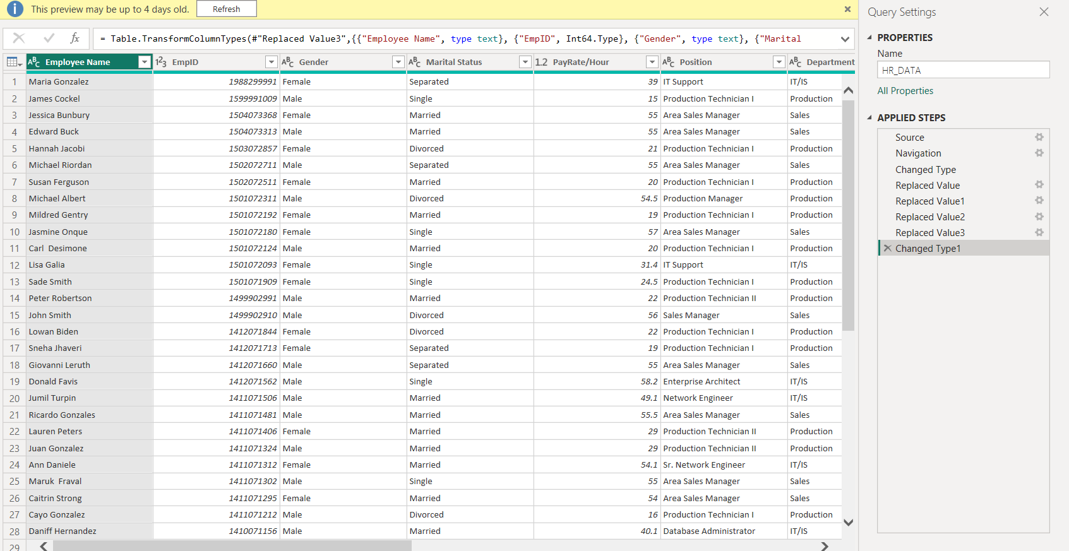

These data preprocessing steps have allowed us to work with a clean and reliable dataset, ensuring that our analysis is based on accurate information and yielding meaningful insights for our HR analysis

**Report Structure**

The report is divided into multiple sections, each focusing on different aspects of HR data:

**HR Analytics Dashboard**

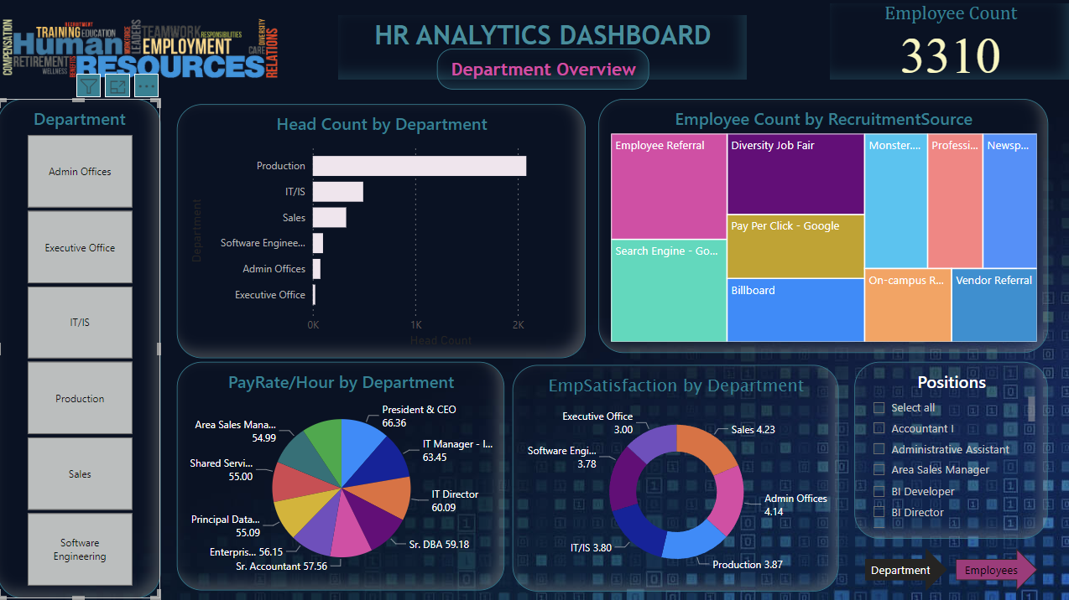

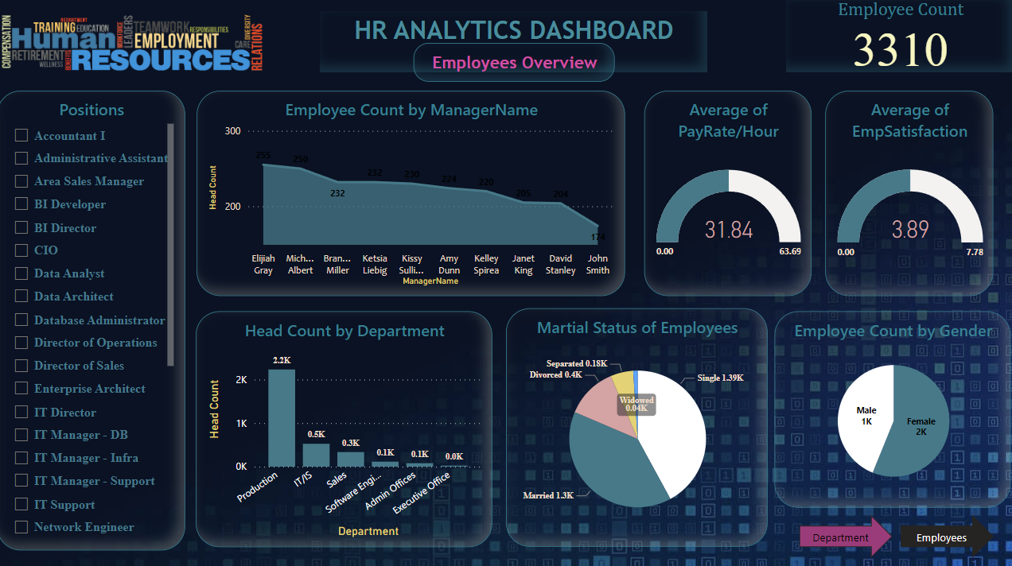

**Page 1: HR Analytics Dashboard - Department Overview**

Page Heading: HR Analytics Dashboard

Subtitle: Department Overview

Content:

* **Summary Metrics**:
  + Card visualization displaying the total employee count.
  + Slicer tile visualization allowing users to filter data by departments.

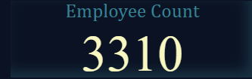

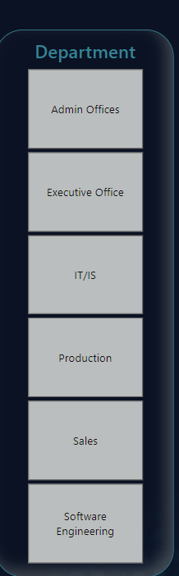

* **Headcount by Department**:
  + Clustered bar chart illustrating headcount by department.

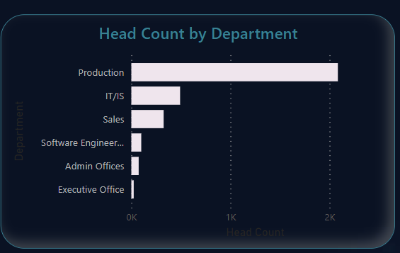

* **Recruitment Source Analysis**:
  + Matrix visualization displaying recruitment source values (e.g., "First Recruitment Source") by position and headcount.

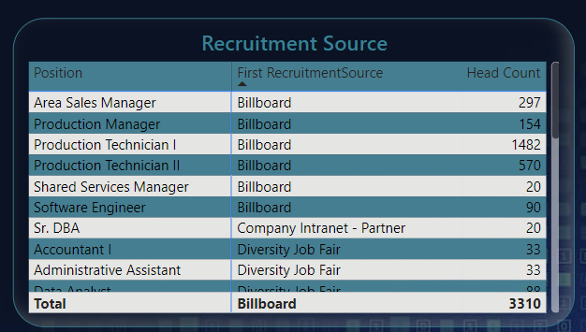

* **Pay Rate by Department**:
  + Pie chart showing pay rate by department, where the legend represents position and the values are the average pay rate per hour.

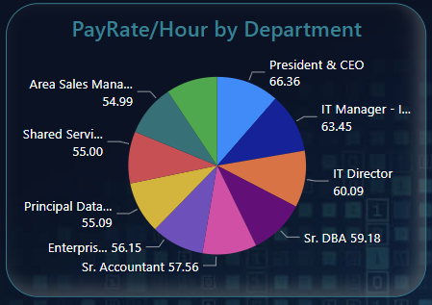

* **Employee Satisfaction by Department**:
  + Donut chart presenting employee satisfaction by department. The legend represents the department, and the values represent the average employee satisfaction.’

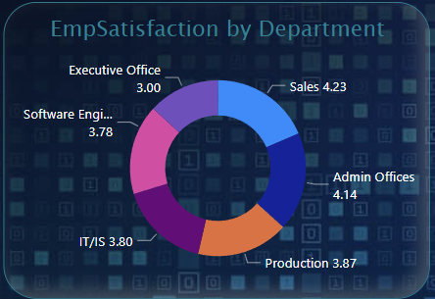

* **Slicer for Position**:
  + A slicer allowing users to filter data by position.

.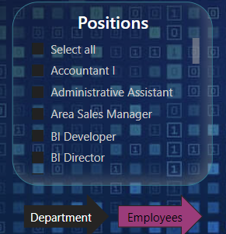

**Page 2: HR Analytics Dashboard – Employee Overview**

Page Heading: HR Analytics Dashboard

Subtitle: Employee Overview

Content:

* **Filters**:
  + Slicers for Position: Allow users to filter data by position.
  + Years Slicer: Choose the range of years to analyse.

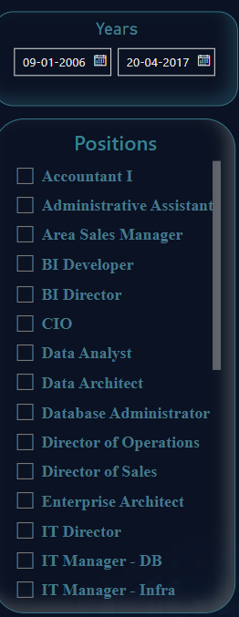

* **Summary Metrics**:
  + Card visualization displaying the total employee count.

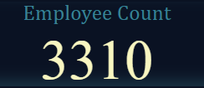

* **Employee Count by Manager Name**:
  + Area chart illustrating employee count by manager name over time.

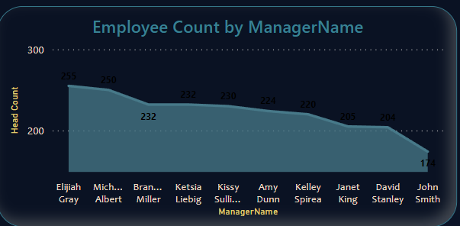

* **Headcount by Department**:
  + Clustered column chart presenting headcount by department.

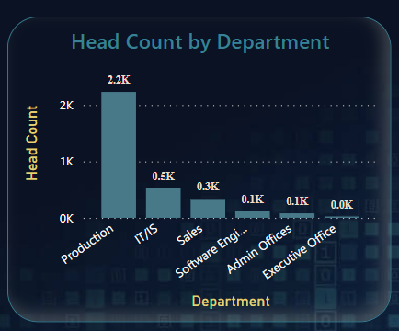

* **Marital Status and Gender Distribution**:
  + Pie chart showing the marital status of employees.
  + Pie chart illustrating the employee count by gender.

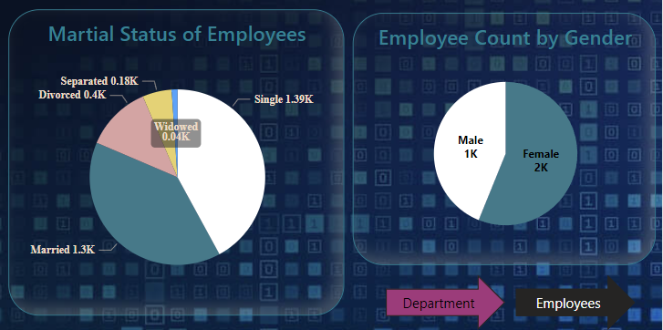

* **Gauge Visualization**:
  + A gauge displaying the pay rate per hour.
  + Another gauge displaying employee satisfaction.

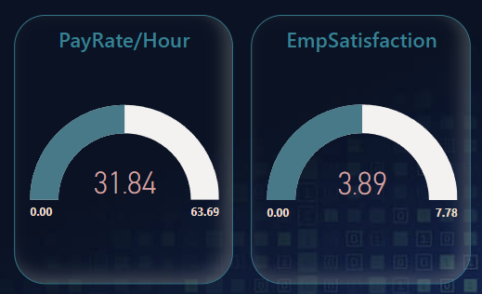

The provided structure allows you to present your HR data effectively with a focus on different aspects in the HR analytics dashboard and employee overview sections. You can customize the visualizations, add further details, and make any necessary adjustments to fit your specific HR data and reporting requirements.

**Conclusion**

**1. HR Overview Insights**

* The organization currently employs a total of [Total Employee Count] dedicated and talented individuals.
* [Department Slicer Selection] departments make up our workforce, with distinct headcount compositions.
* A breakdown of our workforce shows a variety of sources, with [First Recruitment Source] being the most common.
* Our pay rates per hour, on average, exhibit departmental variations, indicating potential opportunities for further investigation.
* Employee satisfaction levels vary by department, and our data highlights areas with both high and low satisfaction levels.

**2. Employee Overview Highlights**

* Our workforce includes employees with diverse backgrounds and roles.
* Employee count varies significantly depending on the selected position, and this data can inform recruitment and talent management strategies.
* Over the years, employee count has shown trends by manager, providing insights into leadership effectiveness and team dynamics.
* Departmental headcounts showcase variations, with implications for resource allocation and department-specific strategies.
* The marital status of our employees reveals valuable insights for benefits and support programs.
* Gender distribution is balanced, reflecting our commitment to diversity and inclusion.

**3. The Bigger Picture**

Our HR data analysis goes beyond the specific pages and visualizations presented in this report. By delving into departmental trends, employee demographics, and the evolution of our workforce, we gain valuable insights for better decision-making. The report structure offers flexibility and interactivity, enabling users to explore the data from multiple angles.

**4. Next Steps**

As we conclude this analysis, it's important to consider the next steps:

* Continuously monitor HR data to ensure it remains accurate and up-to-date.
* Use the insights from this report to develop targeted HR strategies and initiatives.
* Collaborate with department heads and HR professionals to address specific findings and trends.
* Promote a culture of data-driven decision-making within the organization.